Accounting Seminar
October 25, 2018
Hilton Garden Inn
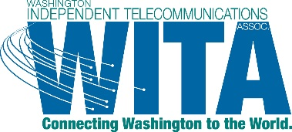
2101 Henderson Park Lane SE
Olympia, WA 98501

AGENDA

8:30 – 9:00 Registration/Check in
9:00 – 12:00 RJ DelMese, Moss Adams - Maximizing the Return on Your System
- CBOL - Standalone Broadband – How Do We Make It Pay?
- What Needs to Be Done for Reporting and Cost Study Purposes?
  - What expenses are excluded from the cost study?
- Copper, Fiber, Modems, ATAs and How We Manage Cost Recovering of Those Systems

10:00 – 10:15 Morning Break

12:00 – 12:45 Lunch (provided)

12:45 – 2:15 Emily Verdonk, Morris and Verdonk - The Five Steps to Revenue Recognition & Accounting Practices
- The new five-step revenue recognition model could affect your bottom line in the transition year. Have you walked through each step yet? Does this affect your contracts? Will your company need new processes in place? This interactive activity will walk you through the 5 steps to determine any changes in how revenue is recognized in your company. Have peace of mind that your contracts and revenue are being recorded in an accurate and timely fashion.
- Accounting Practices Q&A - submit your questions around accounting practices beforehand and we will review best internal finance practices.

2:15 – 2:30 Afternoon Break

2:30 – 3:00 Betty Buckley, WITA Executive Director - Legislative Update
- Progress Towards the Continuation of the State USF and How You Can Help
- Other Legislation That Could Impact Our Member Companies
  - Governor’s Omnibus Broadband Bill
  - PUD Retail Authority
- Potential Federal Funding for Broadband Projects (USDA)

3:00 – 3:45 Brooke Ogg, Hood Canal Communications – Grant Writing Tips
What works and what to avoid when applying for a USDA grant

